MIDN McKenzie Eshleman

221938

SY303 3321

Project one Engagement

Gate 1. DMux8Ways

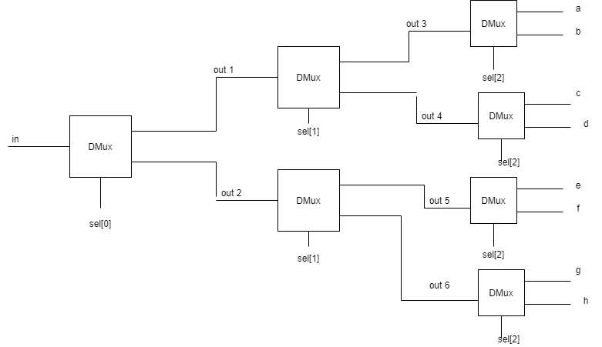

Gate 2. Mux8Way16

